July 29, 2025

Dear SAVA Students and Families:

Welcome to the 2025-2026 school year at Santa Ana Virtual Academy (SAVA)!

I am honored to continue serving as your principal this year and want to extend a warm greeting to our continuing students and families, and especially to new students joining SAVA this year.

As we embark on the new school year, I am thrilled to announce the establishment of SAVA as an alternative school of choice for students in grades 4-12. SAVA will continue to offer a flexible and engaging learning environment that caters to the needs of our families, ensuring access to high-quality, public education for all.

Although this is an exciting time for our school, many families are feeling deep concern and anxiety due to recent immigration enforcement activities in our community. To that end, I want to share clearly and sincerely: our school is committed to being a safe, welcoming, and supportive space for every student and family regardless of immigration status.

What This Means for Our School Community
- ICE agents are not allowed on campus unless they present a valid judicial warrant or assert exigent circumstances.
- We do not collect or share information about students or families unless legally required to do so.
- Student education records are protected under FERPA and California privacy laws. No information will be released without your written consent, except by court order or subpoena.
Supports in Place for Students and Families
- The district and partnering organizations monitor immigration enforcement activities in our community to ensure the safety of our students, families, and staff.
- All school staff have received training on how to respond if federal agents approach our campus or ask for access.
- FACE has compiled multilingual resources about legal rights, local support services, and emotional wellness resources available to students and families.
- Counselors, front office staff and our FACE Liaison are available to assist families and other community members in accessing information and available resources (workshops, pantry/food distribution, Know Your Rights Red Cards, mental health services).
Important information and dates for the 2025-2026 school year:

First Day of Instruction

Classes begin Monday, August 11th. Please refer to the 2025-2026 bell schedules for elementary (grades 4-5) and secondary (grades 6-12) students, included in this communication.

Program Verification for New and Continuing Students

All students who were enrolled in SAVA in 2024-2025 and are continuing with us in 2025-2026 are required to attend Program Verification accompanied by a parent/guardian. Program verification will take place in the multi-purpose room (MPR), located on our campus at 1512 West Santa Ana Blvd., Santa Ana, CA 92703 as follows:

- Program Verification is scheduled for July 28 – 31, 2025 (please see scheduled dates and times below).

- Attendance to program verification is mandatory.

- All students must be accompanied by a parent/guardian on the scheduled dates/times.

- Families with more than one student enrolled in SAVA will select one day (from the scheduled dates) to complete program verification for all students attending SAVA in 2025-2026.

- Parents and students are required to sign a new master agreement for each student enrolled in SAVA for the 2025-2026 school year.

- Instructional materials and school supplies will be distributed to students during program verification.

- Students do not need to bring their school-issued laptops to program verification unless it is not working properly.

- Students who experience poor connectivity from home can request a hotspot during program verification.
Program Verification Schedule
For questions regarding program verification, please contact the SAVA office at 714/565-5450 or visit our website: Office hours are 7:30 AM – 4:30 PM, Monday – Friday.

Note: Please remember that students will not be able to access their classes until a master agreement for the current year, 2025-2026 is signed by the student and the parent/guardian. If you are unavailable to attend program verification, please contact our office at 714/565-5450 for further guidance and assistance. At SAVA, it is our priority to ensure all students are equipped with the tools they need and ready to learn the first day of instruction, Monday, August 11, 2025.
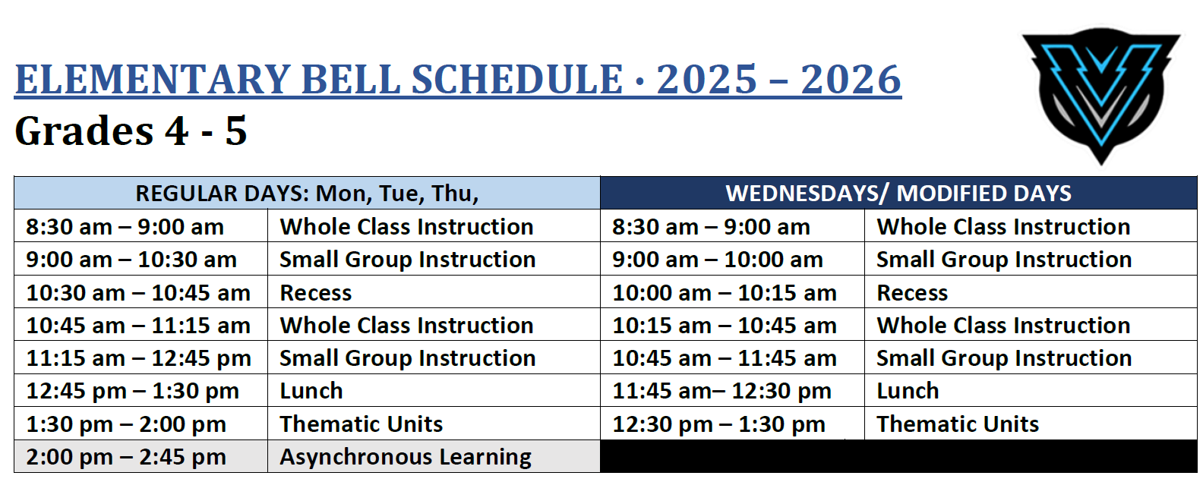
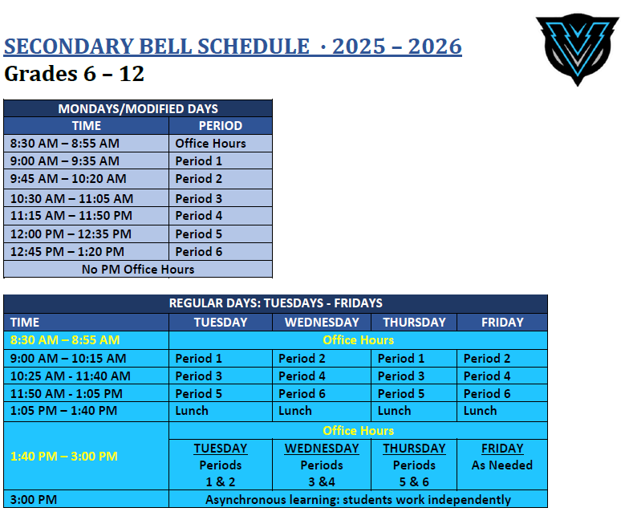
Block Schedule:
Students in grades 6-12 will follow a block schedule:
- Periods 1-6 classes will meet on Mondays
- Periods 1, 3, and 5 classes will meet Tuesdays and Thursdays
- Periods 2, 4, and 6 classes will meet on Wednesdays and Fridays

Teacher Office Hours – Fall Semester:
- 8:30-8:55 AM Monday-Friday
- 1:40 – 3:00 PM Tuesdays - Periods 1 & 2 Classes
- 1:40 – 3:00 PM Wednesdays – Periods 3 & 4 Classes
- 1:40 – 3:00 PM Thursdays – Periods 5 & 6 Classes
- 1:40 – 3:00 PM Available by appointment

How to Access Class(es) the First Day of School, Monday, August 11, 2025

Teachers and students in grades 4-12 will use Canvas, the District’s supported learning management system, to complete class assignments, access instructional resources, and submit completed work as required. Students will access their canvas courses and teachers via Zoom link.

Elementary Students, Grades 4-5

- On or before Friday, August 8, teachers in grades 4-5 will email their students and parents a welcome message including the Zoom link to access their Canvas course on Monday, August 11, 2025 (first day of instruction). Class will begin promptly at 8:30 AM.

- Parents/students who have not received communication from the assigned teacher via email or ParentSquare message prior to the first day of instruction, Monday, August 11, must contact the SAVA office at 714/565-5450 to inquire about their student’s assigned teacher and Zoom link.
Secondary Students, Grades 6-12
- Students enrolled in grades 6-12 will use their Aeries student Portal to view their class schedule including all courses they are enrolled in and the Zoom link to access each course listed.

- Monday, August 11, 2025 (first day of instruction) students will meet their assigned teachers for periods 1-6. Students must log into their period 1 class promptly at 9:00 AM.

- Students are strongly encouraged to check their school email frequently throughout the school year, including the weekend prior to the start of the school year for any last-minute updates or communication from their teachers.
To our students, I encourage you to embrace the opportunities that this new school year brings. Stay curious, ask questions, and take an active role in your learning. Teachers, counselors, and our staff are committed to providing a safe space where each of you can thrive academically and feel valued for your participation and contributions to your classes and the SAVA community of learners.

To our families, I want to thank you for your continued partnership in the education of your child, and for your advocacy in ensuring all students have access to well-rounded and engaging learning experiences. Your support and involvement are crucial to the success of individual students, our school, and the community at large. I look forward to our collaboration this year. If you have any questions or need assistance, please do not hesitate to contact us. We are here to support and are committed to making this school year a successful and memorable experience for all. Again, welcome to the 2025-2026 school year!

With much appreciation,
Erica Graves, Principal
Santa Ana Virtual Academy/
Independent Study Program
Santa Ana Unified School District
erica.graves@sausd.us

